Confirmation email:

- The following should be added in the ‘How do I make a claim section?’

Norwegian | Rapporter kravet ditt via {{ClaimsURL}}
English | Report your claim via (ClaimsURL)

For reference only, something similar is implemented for Spain Spanish confirmation email.

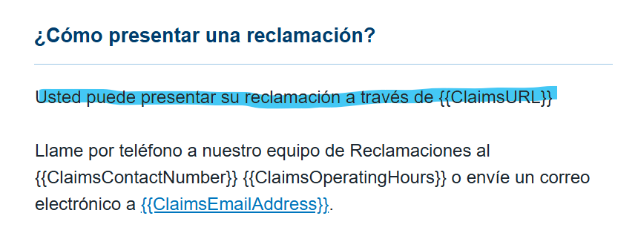

- Remove the alternate language links as they’re no longer applicable
- Please separate the {CustomerServicesURL} from the {CustomerServicesEmailAddress}, see UA example.
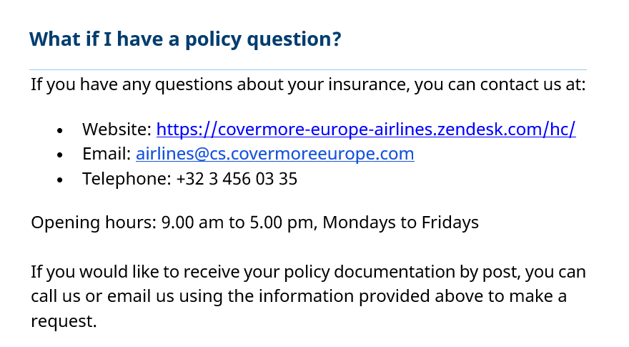

English | If you have any questions about your insurance, you can contact us at:  - Website: {{CustomerServicesURL}}  - Email: {{CustomerServicesEmail}}  - Telephone: {{CustomerServicesNumber}}  Opening hours: {{CustomerServicesOpeningHours}}  If you would like to receive your policy documentation by post, you can call us or email us using the information provided above to make a request.
Norwegian | Hvis du har spørsmål om forsikringen din, kan du kontakte oss på:  - Nettsted: {{CustomerServicesURL}}  - E-post: {{CustomerServicesEmail}}  - Telefon: {{CustomerServicesNumber}}  Åpningstider: {{ CustomerServicesOpeningHoursLocal}}  Hvis du ønsker å motta polisedokumentasjonen din i posten, kan du ringe oss eller sende oss en e-post ved å bruke informasjonen ovenfor for å sende en forespørsel.

